Machine Learning in Finance

Lab Logbook Requirement:
- Create your own Multi-layer Perceptron (MLP) with two hidden layers, where the first hidden layer cells' number equals the last three digits of your SID. The number of cells in the next hidden layer is approximately two times smaller.
For example, if your SID is 2287167, the number of cells on the first hidden layer is 167, and on the second - 84. Take epochs=10. Leave other parameters the same as in the practical session.
- Compile the model.
- Train your MLP with the same datasets and demonstrate the received MAE on the test dataset.
- Compare your MAE with the MAE of the MLP in the practical session.
- Please only add to your Lab Logbook a print-screen(s) of your MLP architecture using model.summary(), MLP training code and process, and the resulting MAE on the test dataset.

Sol:
model=keras.Sequential([
keras.layers.Dense(517,input_dim=500,activation=tf.nn.relu,kernel_initializer="normal"),
keras.layers.Dense(259,activation='relu',kernel_initializer="normal"),
keras.layers.Dense(130,activation='relu',kernel_initializer="normal"),
keras.layers.Dense(1)])
print(model.summary())
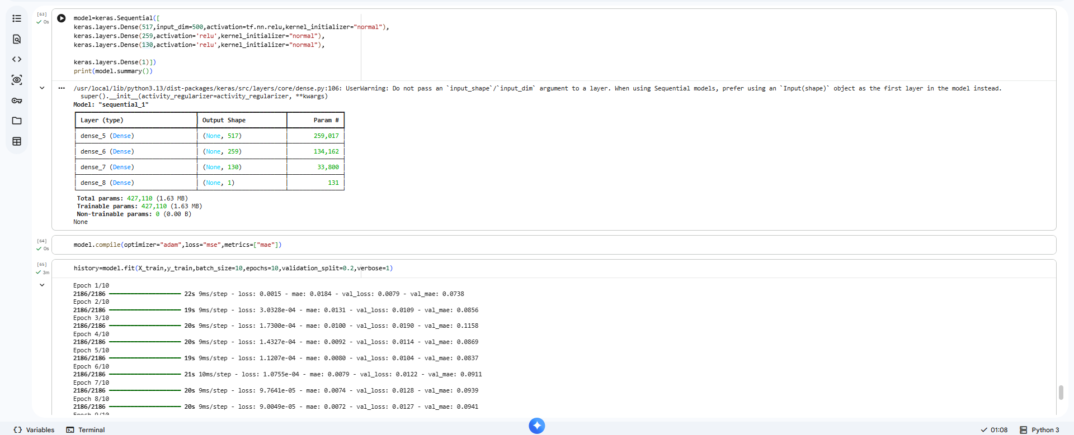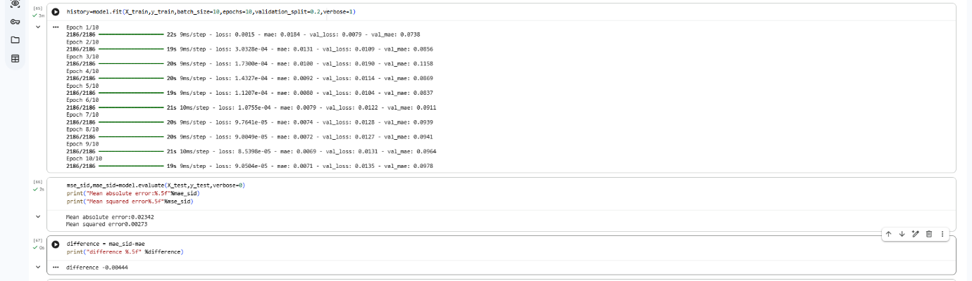
model.compile(optimizer="adam",loss="mse",metrics=["mae"])

mse_sid,mae_sid=model.evaluate(X_test,y_test,verbose=0)
print("Mean absolute error:%.5f"%mae_sid)
print("Mean squared error%.5f"%mse_sid)

difference = mae_sid-mae
print("difference %.5f" %difference)

